Standard Operating Procedure (SOP) for Organized Development of Funnels and Email Automation in Go High Level - Spybriefing

Introduction
This Standard Operating Procedure (SOP) outlines the guidelines and conventions to be followed by Spybriefing developers for the structured and organized development of funnels and email automation in GoHighLevel. By adhering to these guidelines, we ensure consistency in naming, ordering, and URL structure, which enables streamlined development and enhances overall clarity within our projects.

Setting up the funnel
When you go to the GHL funnel builder, the first thing that needs to be done is to go to the settings tab. From there, select the domain that we will be using for the funnel, which in this case will be vip.spybriefing.com
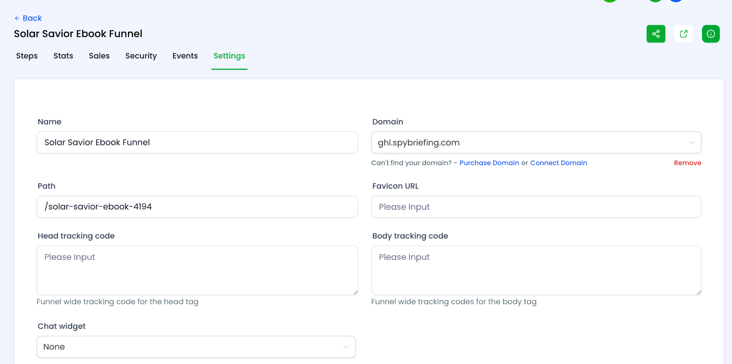

Naming Convention for Funnels
To effectively identify funnels, the following guidelines must be followed.
- Begin with the funnel name in the format: `<Funnel Name> Funnel`. For example, if the funnel is named "Blade Warrior," it becomes "Blade Warrior Funnel."

Naming Convention for Funnel Per Advertiser
Some of the funnels have specific advertisers. For example, you may have a RAT Fight Funnel for Dan and another one for Sunset. Both these funnels need to be labeled accordingly.
- Begin with the funnel name in the format: `<Funnel Name> Funnel (Name Of Advertiser)`. For example, if the funnel is named "RAT Fight," and the advertiser is Dan, it becomes "RAT Fight Funnel (Dan)"

Naming Convention for funnel steps
Each funnel step in GHL should be clearly labeled as a Lead Page, Upsell, Order Form, or Downsell. See example below
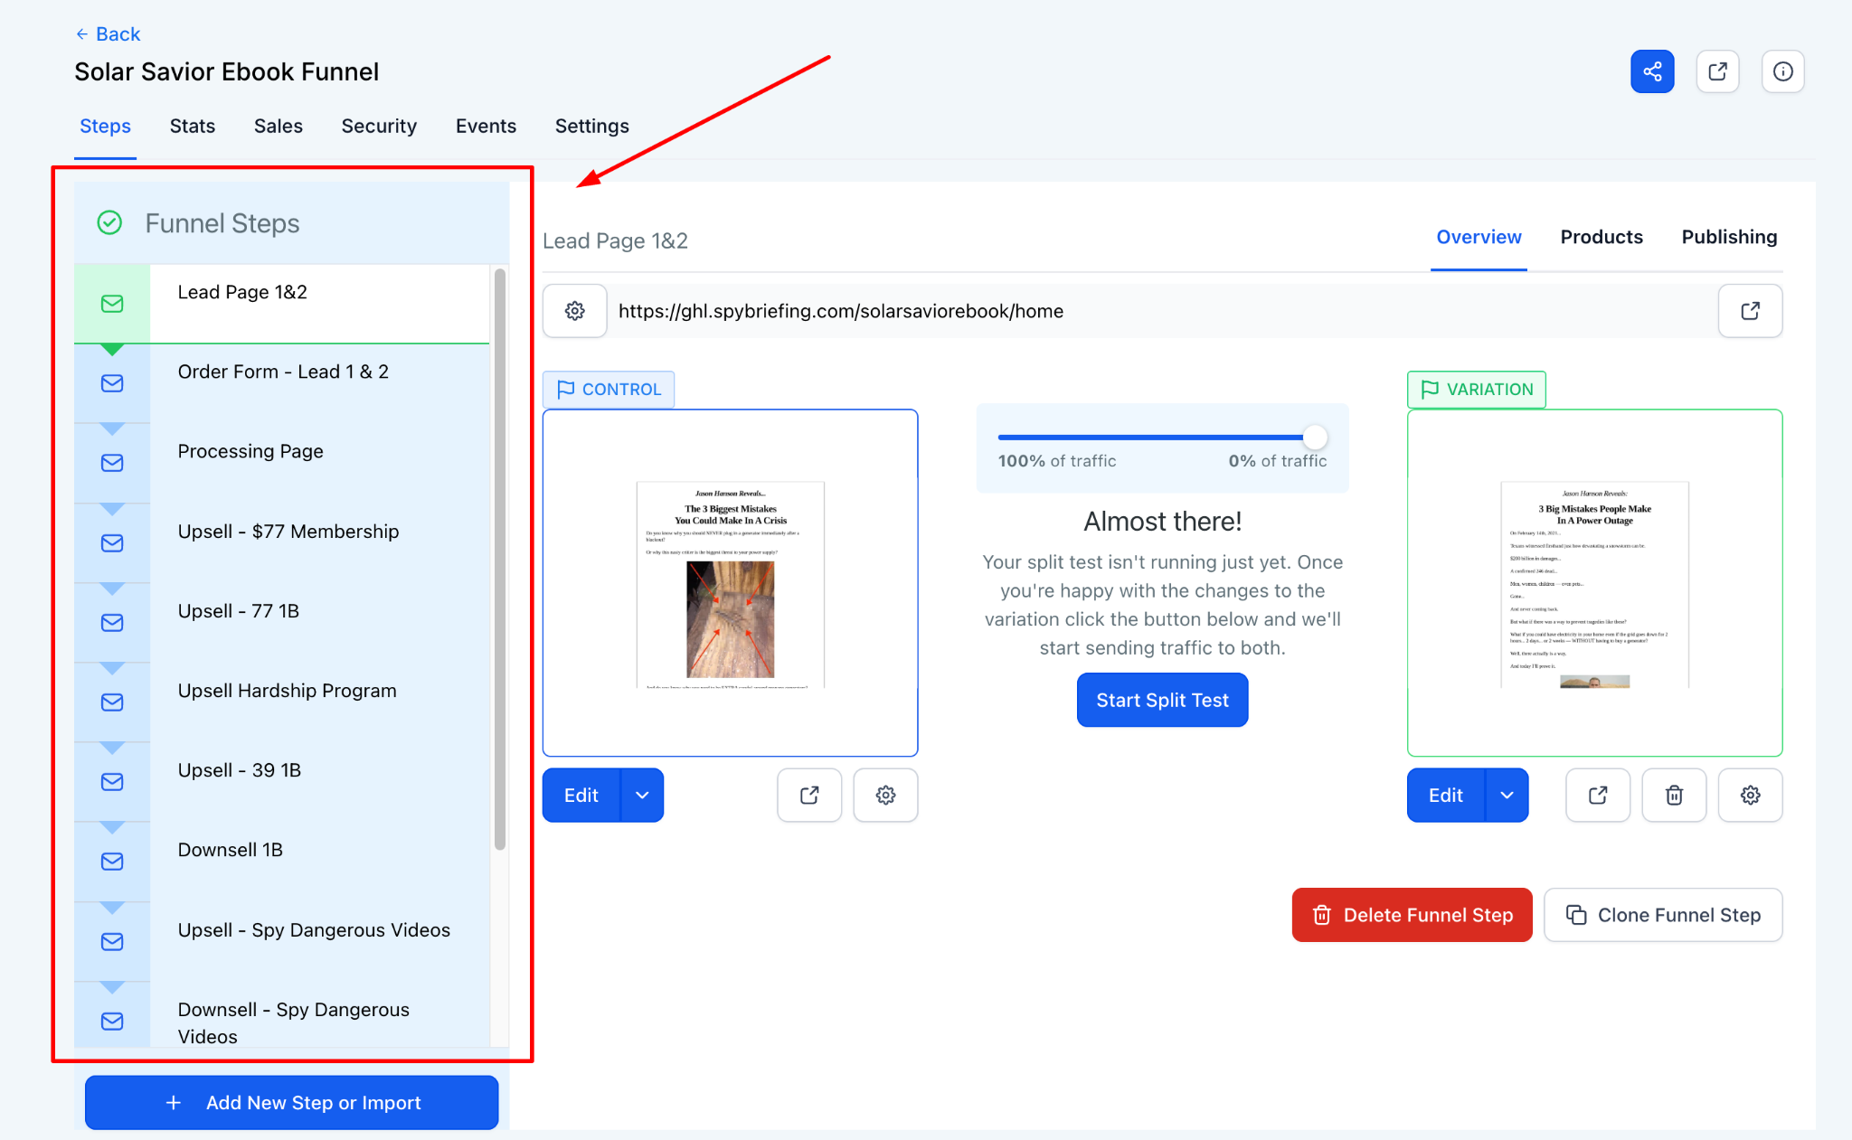

URL Structure for Funnel Steps
When generating URLs for different funnel pages/steps, follow these guidelines:
- Landing Page URL: Use the format `vip.spybriefing.com/funnelname/home` for the landing page of the funnel. If it is a funnel for Sunset, Dan, Dave B, etc, use their initials. So it would look like this vip.spybriefing.com/funnelname/home-s for Sunset. If the URLs clash, GHL will automatically add numbers to the URL. We do not want this, so adjust until you have a URL that has no random numbers.
  - Each funnel step has at least one control; this information is listed under the page details. Ensure the sub URL is properly set up. The format should be /funnelname/lp1 for the control, lp2 for the variation.
  - If the funnel has more than 2 lead pages, then the 3rd and 4th lead pages will be lp2 & lp3, respectively.
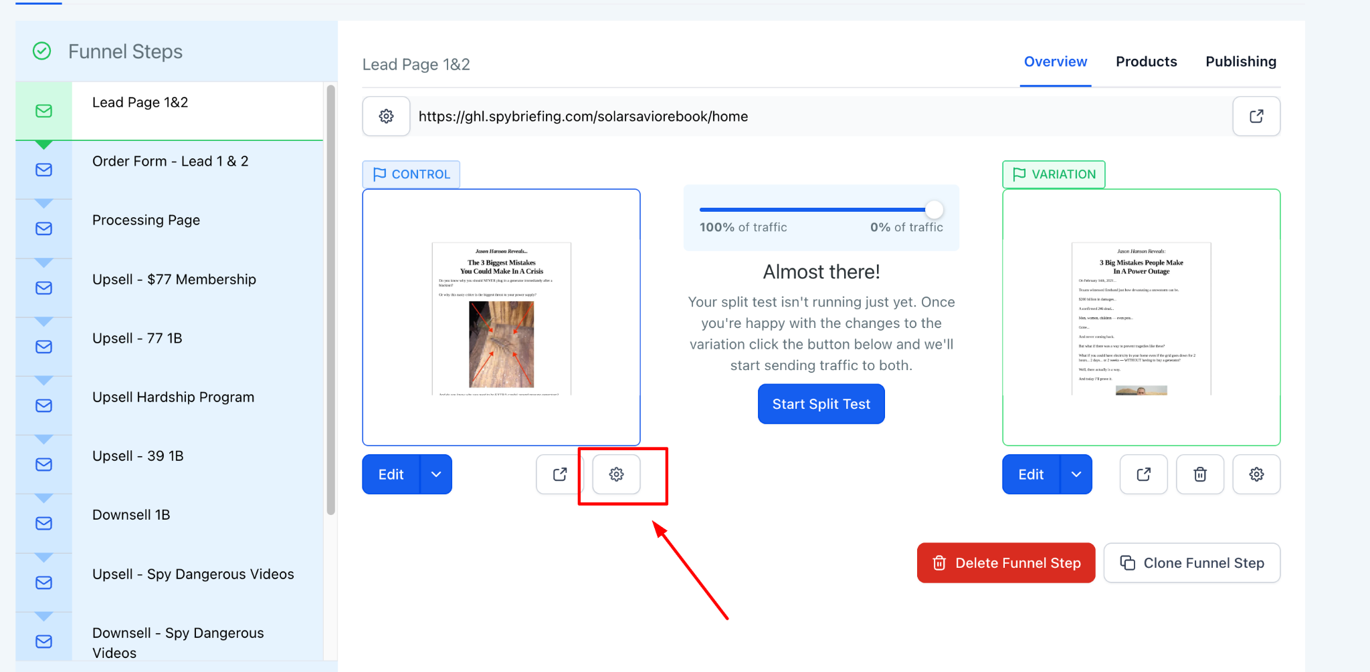
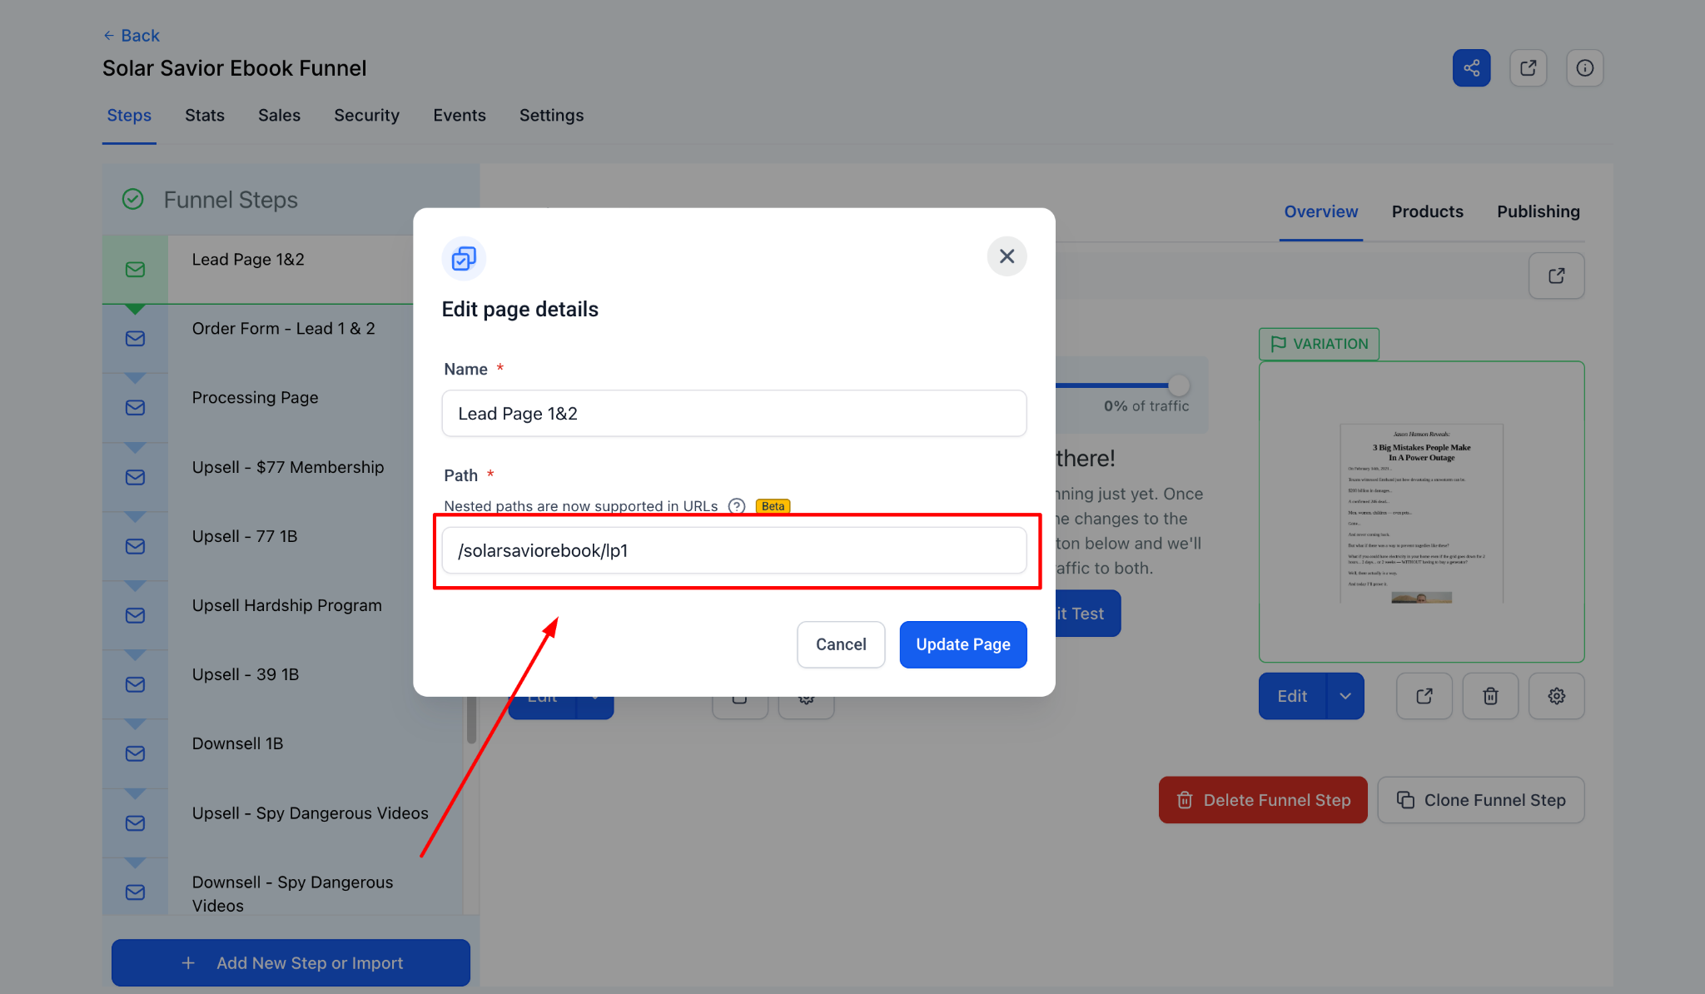
- Product Steps URL: Utilize the structure `vip.spybriefing.com/funnelname/nameoftheproduct`. If there are multiple product variations, append a numerical identifier (e.g., `vip.spybriefing.com/funnelname/nameoftheproduct1`).
  - If the funnel is associated with a particular advertiser, please use their initials at the end of the URL.
    - Let's say this advertiser is Dan, the URL would be vip.spybriefing.com/funnelname/nameoftheproduct1-d`.
    - Let's say this advertiser is Sunset, the URL would be vip.spybriefing.com/funnelname/nameoftheproduct1-s`.
- Exclude "Upsell" or "Downsell": Do not include the terms 'upsell' or 'downsell' in the URL path.
- Adjust for "Upsell" or "Downsell": If the term "downsell" appears in the URL, modify it to 'd.' If the term "upsell" appears, remove it entirely.
Examples:
  - “Upsell 1 - $77 Platinum Membership” would be vip.spybriefing.com/funnelname/platinum-spy-membership
  - “Downsell 1b Stiletto Knife” would be vip.spybriefing.com/funnelname/d-stiletto-knife
  - Notice for the above upsell was not included in the URL, and for the downsell, we simply put “d”
- If the funnel step URL and the page URL are the same, GHL will add strings to one of the URLs; therefore, ensure they don’t clash. As you can see from the screenshots below, URL clashes result in random numbers being added to the URL. This is what we don’t want.
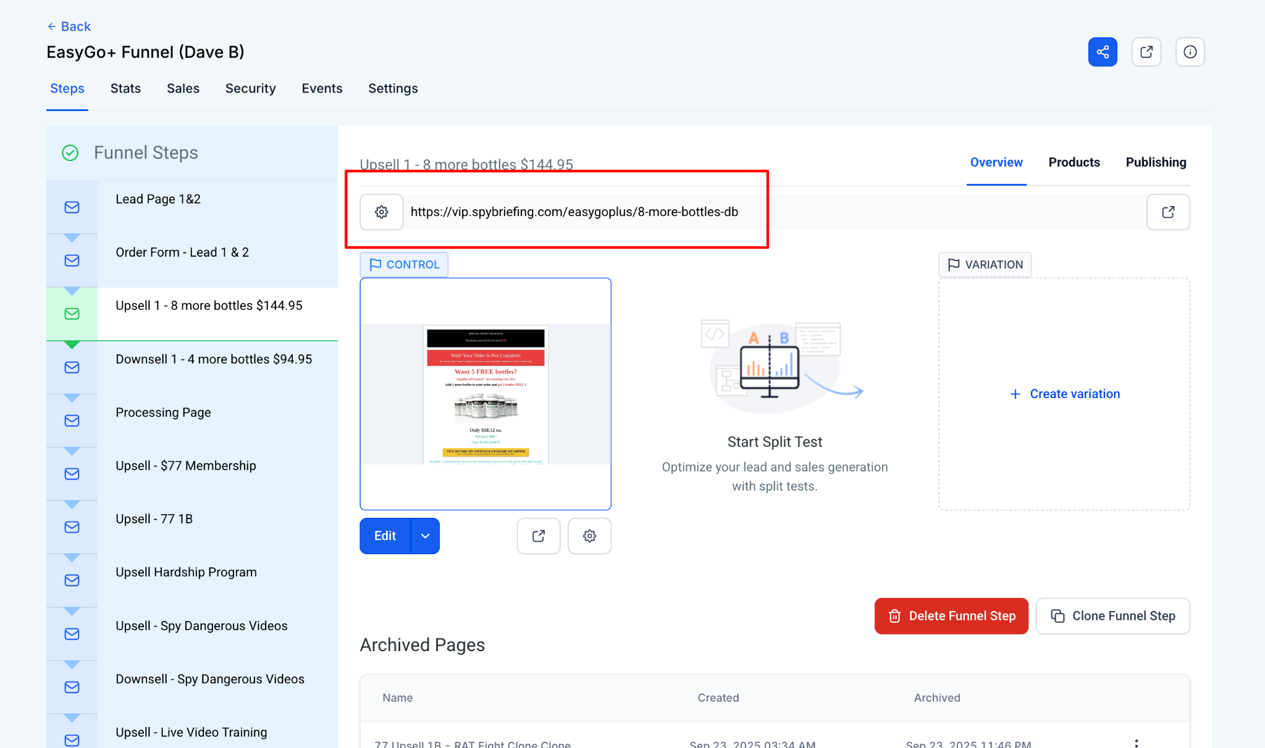
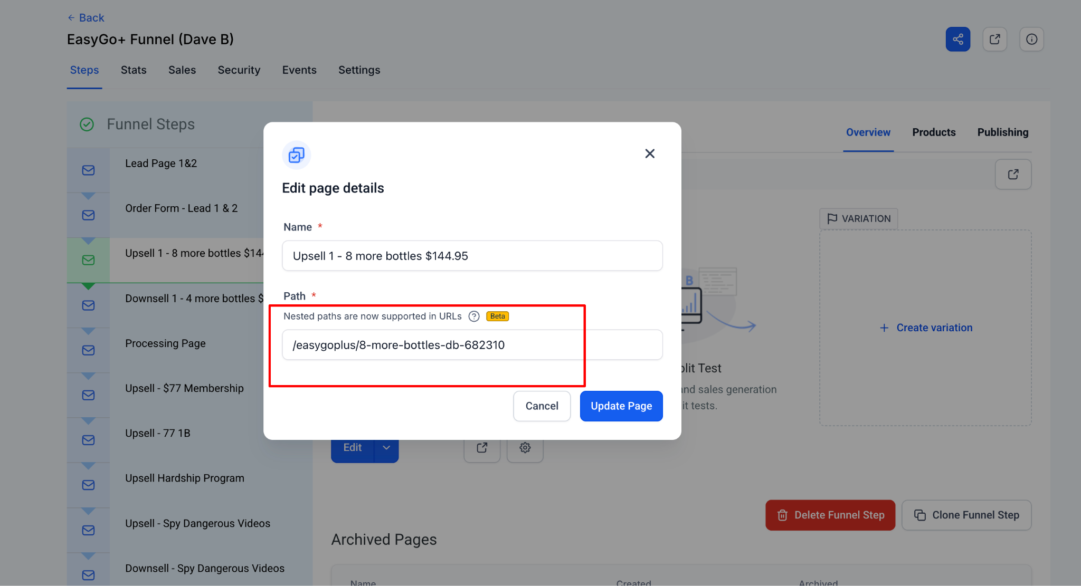

General Styling Guideline For All Funnel Steps
URL Structure for Funnel Steps
- The fonts are set to Roboto
- Font weight must be set to 500-Medium
- Headline font size is 38px and mobile 32px (Unless told otherwise)
  - Line spacing is 1.3 em
  - Text Transform: Normal
  - Letter Spacing: Normal
- Paragraph font size is 25px and mobile 21px
- Subheadline font size is 30px and mobile 22px
- Button font size is 25px and mobile 21px
- Make sure the buttons do not have a checkbox next to them
- Make sure that the SEO Metadata reflects the page content
- Popups on upsell pages should be exit popups
- Optin popups should redirect to the respective order forms.
- Make sure that tracking is set up in the funnel settings
  - Make sure that the tracking code matches the advertiser. Dan, Sunset, etc, all have their own tracking scripts. They can be found here
- For the “NO Buttons” as seen below, use this color 4a86e8 and set the font size to 15, font weight 500.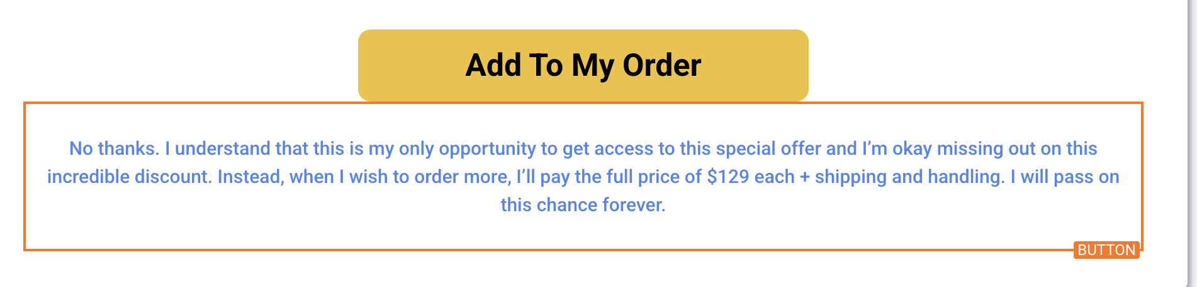

Landing Pages
- If a lead page includes a split test, the corresponding order forms should also be configured as a split test.
  - The control lead page should redirect to the control version of the order form.
  - The variation lead page should redirect to the variation version of the order form.
  - These redirects are managed through the pop-up form. Therefore, the URLs in each pop-up must be set to the correct order form URLs, ensuring that the control points to the control order form and the variation points to the variation order form.
    - To set this up, select the pop-up settings in the funnel edit window. On the right side of the page, select the pop-up you wish to edit. When the pop-up comes up, select the submit button on the pop-up and change the URL.
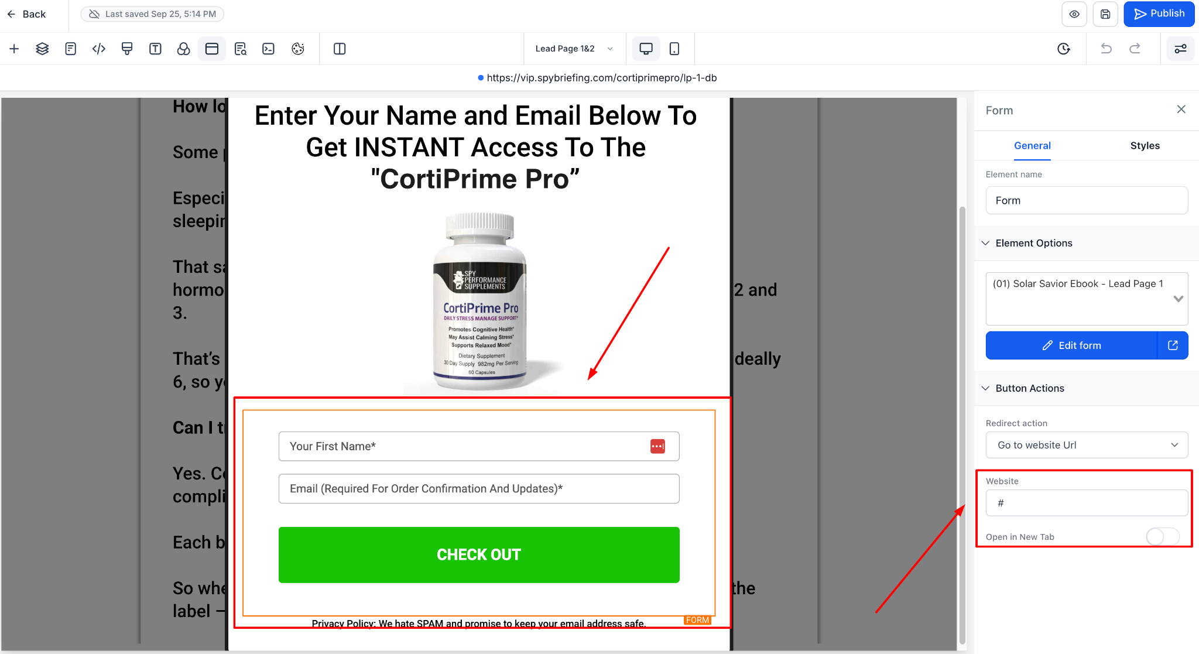
- Make sure the pop-up element matches the name of the product. For example, we can see below that the Element Option on the right says Solar Savior, but it should be CoriPrime Pro.
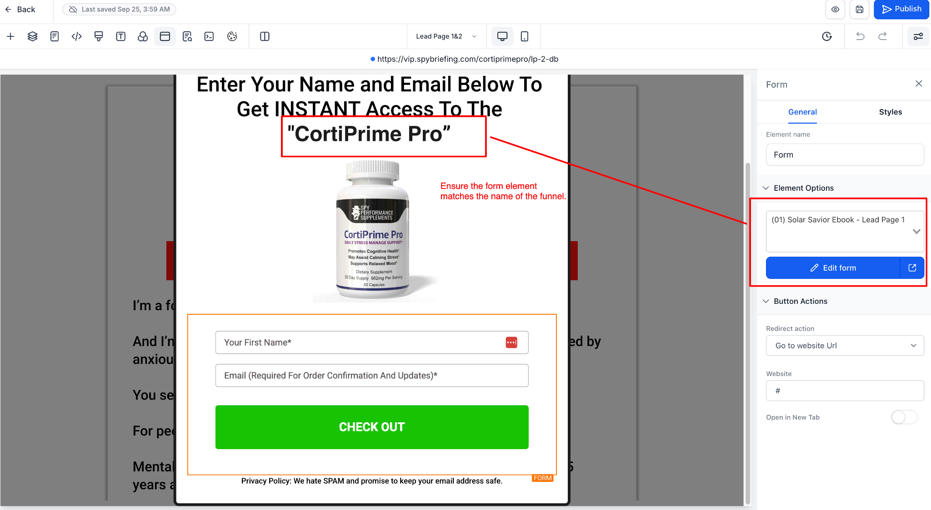
- Ensure the mobile site doesn’t have formatting errors.
- Style the pop-up correctly with the right content.
- Avoid excessive space between paragraphs or sections.
- Confirm buttons open the pop-up.
- The pop-up should contain a space for name and email address
- Quadruple-check for typos or spacing errors in words.

Order Forms
On the order form, make sure that individuals with a blocklist tag do not have access. Follow these steps:
- The fonts are set to Roboto
- Headline font size is 38px and mobile 32px
  - Line spacing for paragraphs set to 48px
- Paragraph font size is 25px and mobile 25px
  - Line spacing for paragraphs set to 30px
- Subheadline font size is 30px and mobile 22px
- Button font size is 25px and mobile 21px
- Make sure the buttons do not have a checkbox next to them
- Make sure that the SEO Metadata reflects the page content

Order Forms - US Only Selection
The script below must be added to a custom HTML on all order forms:
<script>
window.addEventListener('DOMContentLoaded', (event) => {

// ----- SHIPPING COUNTRY (Step 1) -----
setTimeout(function() {
const shippingDropdown = document.querySelector('select[name="country"]');
if (shippingDropdown) {
shippingDropdown.innerHTML = '';
const usOptionShipping = document.createElement('option');
usOptionShipping.value = 'United States';
usOptionShipping.textContent = 'United States';
usOptionShipping.selected = true;
shippingDropdown.appendChild(usOptionShipping);
}
}, 800);

// ----- BILLING COUNTRY (Step 2) -----
// MutationObserver watches for billing dropdown to appear in DOM
const observer = new MutationObserver(function(mutations) {
const billingDropdown = document.querySelector('select[name="countryCode"]');
if (billingDropdown) {
// Lock it to US only
billingDropdown.innerHTML = '';
const usOptionBilling = document.createElement('option');
usOptionBilling.value = 'US';
usOptionBilling.textContent = 'United States';
usOptionBilling.selected = true;
billingDropdown.appendChild(usOptionBilling);

// Stop observing once found and locked
observer.disconnect();
}
});

// Watch the entire document for changes
observer.observe(document.body, {
childList: true,
subtree: true
});

});
</script>

Tracking Setup - General
Make sure that the tracking code matches the advertiser. Dan, Sunset, etc, all have their own tracking scripts. They can be found here.

The tracking script should be placed in the Head tracking code section.
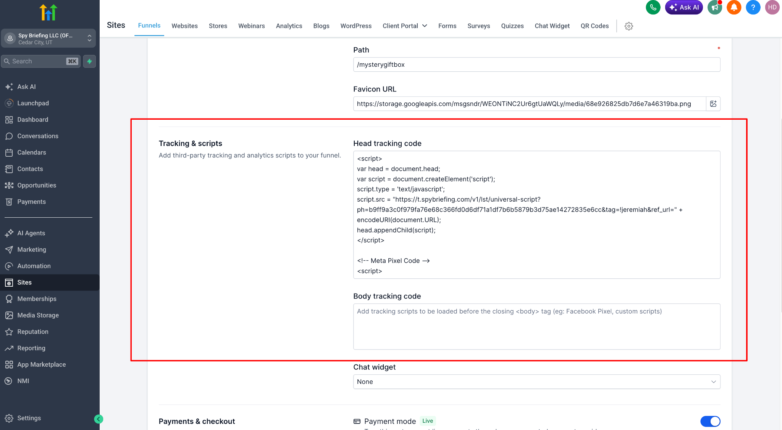

Tracking Setup - Meta
When it comes to tracking for Meta, it is important to track events such as sales, add-to-cart, leads, etc.

Add event tracking to order forms
The script below should be placed on all order forms in the footer tracking
<script>
window.history.forward();
function noBack() {
window.history.forward();
}
</script>
<script>
fbq('track', 'InitiateCheckout');
fbq('track', 'AddToCart');
fbq('track', 'Lead');
(function () {
if (window.__ghlOrderTotalSaverLoaded) return;
window.__ghlOrderTotalSaverLoaded = true;
function saveGhlOrderTotal() {
var pageText = document.body ? document.body.innerText : "";
// Find all Order Total values on the page
var regex = /Order Total\s*\$?\s*([0-9,]+(\.[0-9]{1,2})?)/gi;
var match;
var totals = [];
while ((match = regex.exec(pageText)) !== null) {
var value = parseFloat(match[1].replace(/,/g, ""));
if (!isNaN(value)) {
totals.push(value);
}
}
console.log("Order Total values found:", totals);
if (!totals.length) {
console.log("Order Total not found yet.");
return false;
}
// Ignore 0.00 if a real total exists
var positiveTotals = totals.filter(function (value) {
return value > 0;
});
if (!positiveTotals.length) {
console.log("Only 0.00 total found, waiting for real value...");
return false;
}
var orderValue = Math.max.apply(null, positiveTotals);
sessionStorage.setItem("ghl_order_total", orderValue.toFixed(2));
console.log("✅ GHL order total saved:", orderValue.toFixed(2));
return true;
}
function startChecking() {
console.log("✅ GHL order total saver started");
if (saveGhlOrderTotal()) return;
var attempts = 0;
var timer = setInterval(function () {
attempts++;
if (saveGhlOrderTotal() || attempts >= 120) {
clearInterval(timer);
console.log("Stopped checking for Order Total.");
}
}, 500);
}
if (document.readyState === "loading") {
document.addEventListener("DOMContentLoaded", startChecking);
} else {
startChecking();
}
document.addEventListener("click", function () {
setTimeout(saveGhlOrderTotal, 500);
setTimeout(saveGhlOrderTotal, 1500);
setTimeout(saveGhlOrderTotal, 3000);
});
})();
</script>
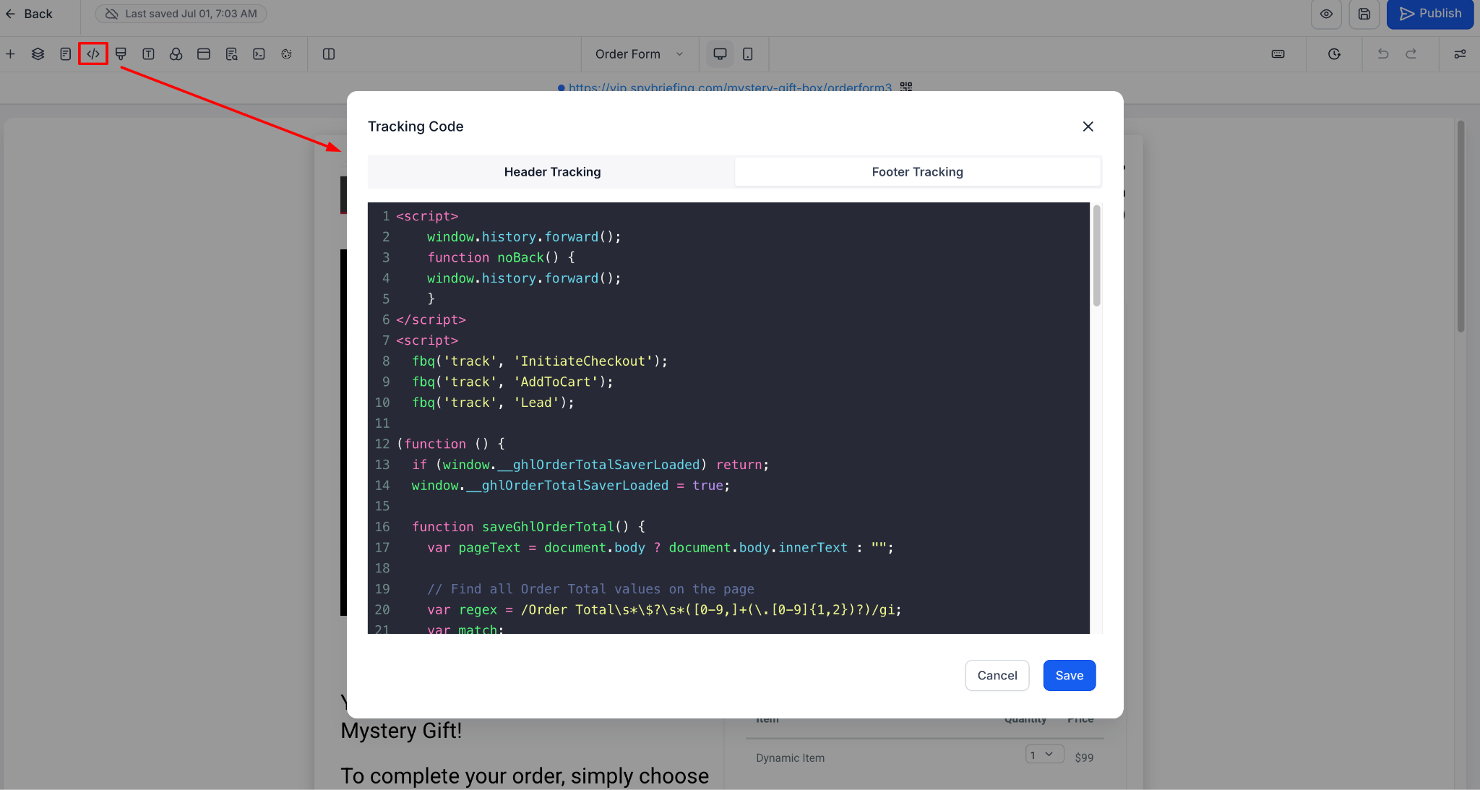

Add event tracking to upsell page
- The tracking script below should be placed on the page that immediately follows the order form, except if it's a processing page.
- To know what pages this should be placed on, open up the processing page, and look at the two URLs that it points to and place it on those pages (control and variation if it exists)
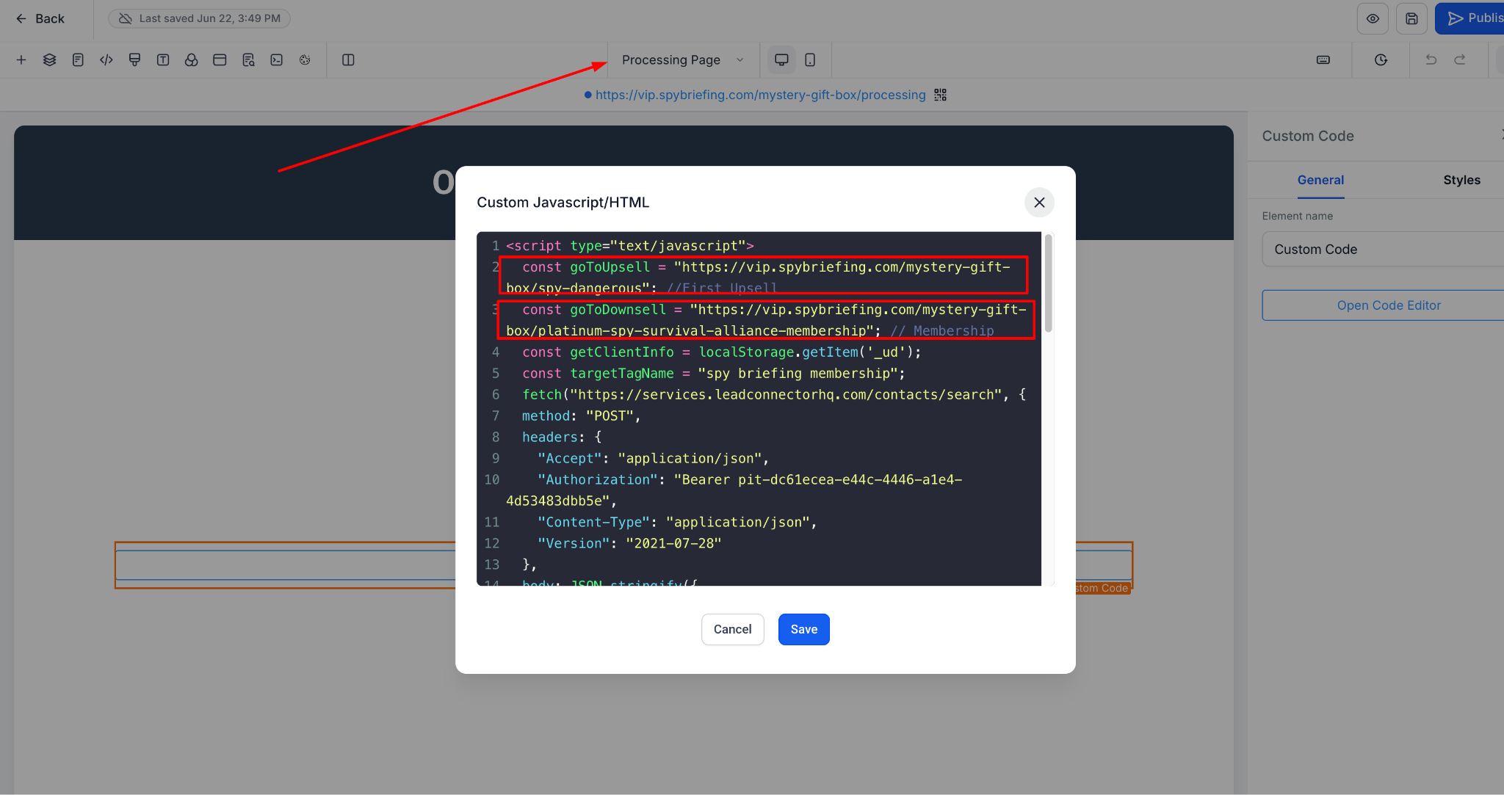
Here is the script to place on those two pages that you have identified.
<script>
window.history.forward();
function noBack() {
window.history.forward();
}
</script>
<script>
(function () {
console.log("✅ Upsell Purchase tracking script loaded");
function firePurchase() {
if (typeof fbq !== "function") {
console.log("fbq not ready, retrying...");
setTimeout(firePurchase, 500);
return;
}
var savedValue = sessionStorage.getItem("ghl_order_total");
var orderValue = parseFloat(savedValue);
if (isNaN(orderValue)) {
console.warn("No saved order value found, using 0.00");
orderValue = 0.00;
}
fbq("track", "Purchase", {
value: orderValue,
currency: "USD"
});
console.log("✅ FB Purchase fired automatically with value:", orderValue);
}
setTimeout(firePurchase, 1000);
})();
</script>

Email Naming Convention
For consistency and easy identification of abandoned cart emails, adhere to the following naming convention:
- For abandoned cart emails, use the format `CA - Name of Product - Lead 1 - Email 1` (or Email 2, Email 3, etc.). 'CA' stands for Cart Abandonment. For example: `CA - Rat Fight - Lead 1 - Email 1`.
  - Each order form should have its own abandoned cart email and automation, so that the sale can be assigned to that order form for split testing purposes.
    - Example:
If a funnel has 3 order forms, let's say they are order form 1, order form 2, order form 3. Then it means the abandoned cart email should be as follows:
`CA - Name of Product - Lead 1 - Email 1`
`CA - Name of Product - Lead 1 - Email 2`
`CA - Name of Product - Lead 1 - Email 3`
`CA - Name of Product - Lead 2 - Email 1`
`CA - Name of Product - Lead 2 - Email 2`
`CA - Name of Product - Lead 3 - Email 3`
- The content of the abandoned cart emails should link back to their respective order forms. Based on the example above, Lead 1 would be linked to order form 1, and Lead 2 would be linked to order form 2.

Abandoned Cart & Fulfillment Automation
In the automation window, there are two folders, one for abandoned cart automations and one for fulfillment automations. Ensure that you add the automation to its respective folder, as shown below.
To maintain clarity in naming Marketing and Fulfillment email automation, follow these guidelines.
- For Abandoned Cart, use the format `MK - Name of Product`. 'MK' stands for Marketing, and 'FF' stands for Fulfillment. For instance: `MK - Rat Fight Book`.
- For Fulfillment, use the format `FF - Name of Product `. FF stands for 'FF'. For instance: `FF - Rat Fight Book `.
When creating the automation, ensure that you add it to a folder and use the above naming convention for the folder. See example below.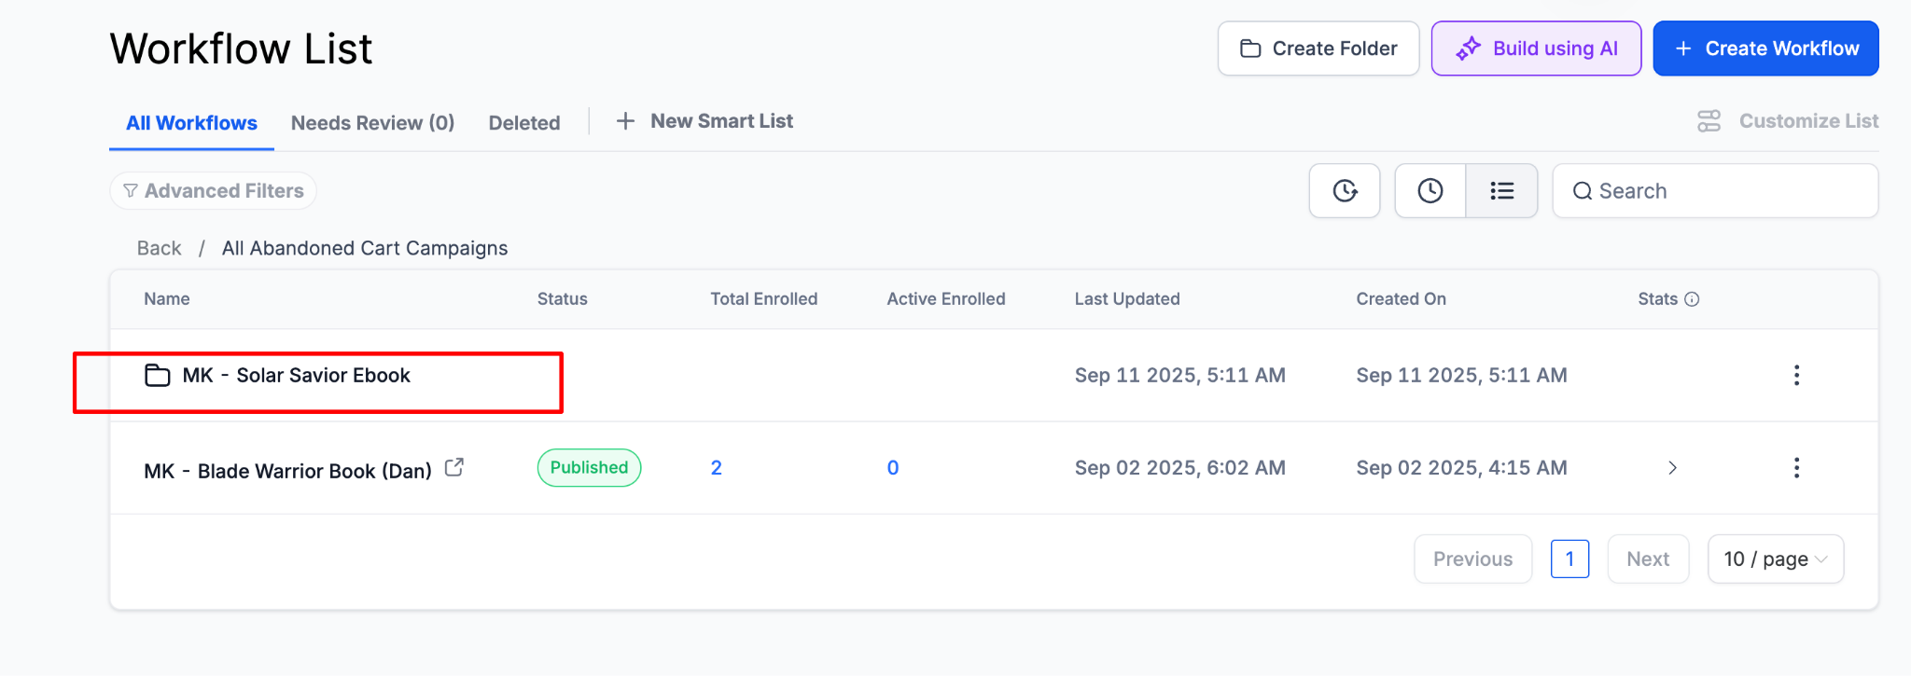
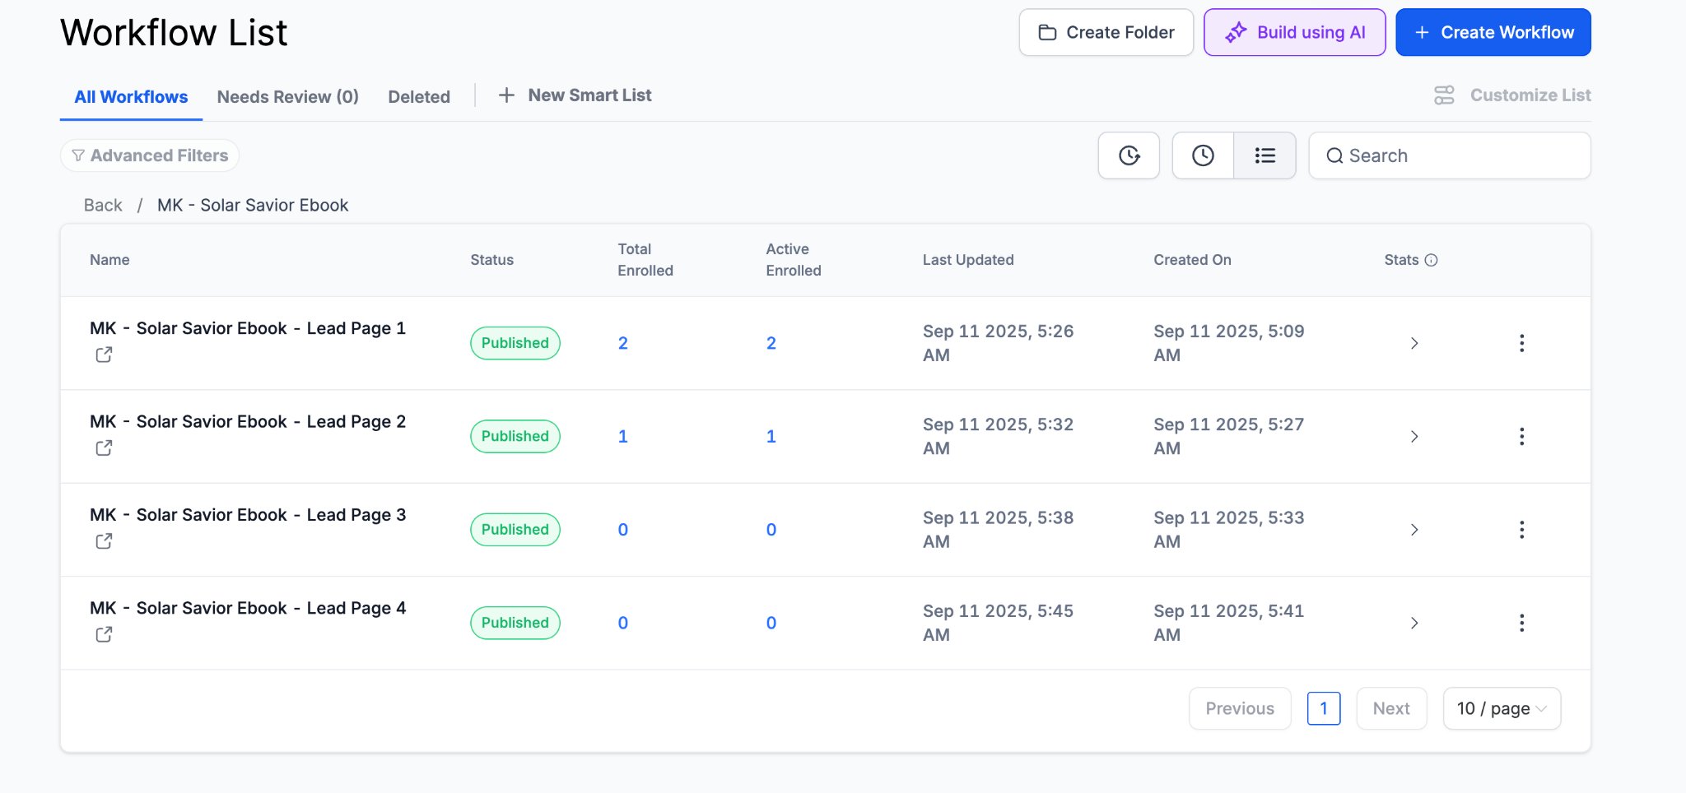
Since the approved automation for Marketing and Fulfillment is MK - Solar Savior Ebook, you can clone that copy and edit it for your funnels accordingly.

Fulfillment Emails Automation
- General Principle:
  - Use the “Payment Received” Trigger
    - When it fires:
      - Whenever a successful payment is processed through your GHL payment integration (Stripe, NMI, PayPal, etc.).
      - It fires after the payment clears — meaning the transaction actually went through.
  - DO NOT USE “Order Submitted” Trigger
  - Each product should have only one fulfillment email automation.
  - Multiple fulfillment automations for the same product are unnecessary, regardless of the number of advertisers or email variations.
- Example:
  - For a funnel named "RAT Fight," which may have variations like "RAT Fight (Dan)" or "RAT Fight (Sunset)," only one fulfillment automation is needed since they share the same product.
  - This is different from abandoned cart emails, where variations such as "MK - RAT Fight" and "RAT Fight (Dan)" are required.
- Implementation Steps:
  - Identify the product and ensure a single fulfillment email automation is created and assigned.
  - Avoid duplicating fulfillment automations for different advertisers or variations of the product.

Email Format
Create email templates for each abandoned cart or fulfillment email. In most cases, it is best to clone an existing email. If possible, always clone an existing email; you can do so with the Solar Savior.
- Email line spacing is set to 1.5x
- Each sentence is a new paragraph, so use Shift + Return x2
- Abandoned cart and fulfillment emails must be sent from jason@spybriefing.com, and the name should say Spy & Survival Briefing
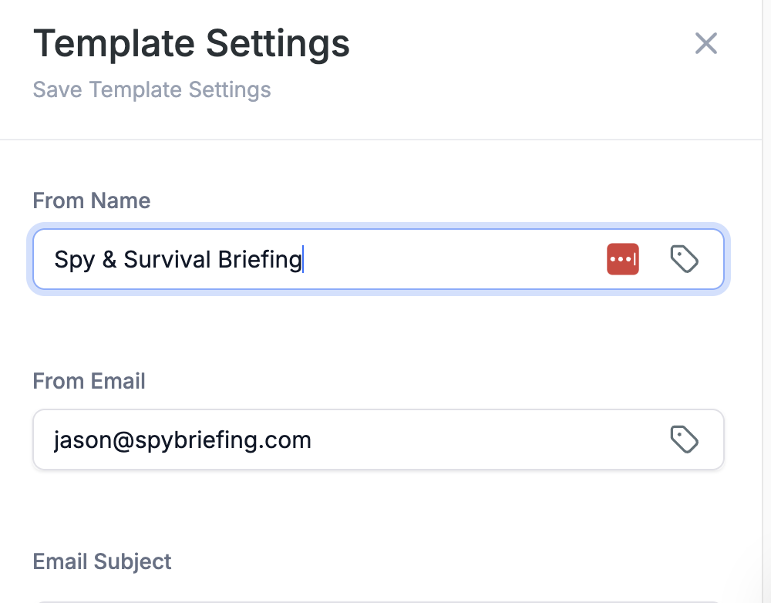
- Preview text should be blank
- Font is Arial 16px for all the text in the email
- Make sure URLs have the correct tracking UTM parameters for the CA emails.
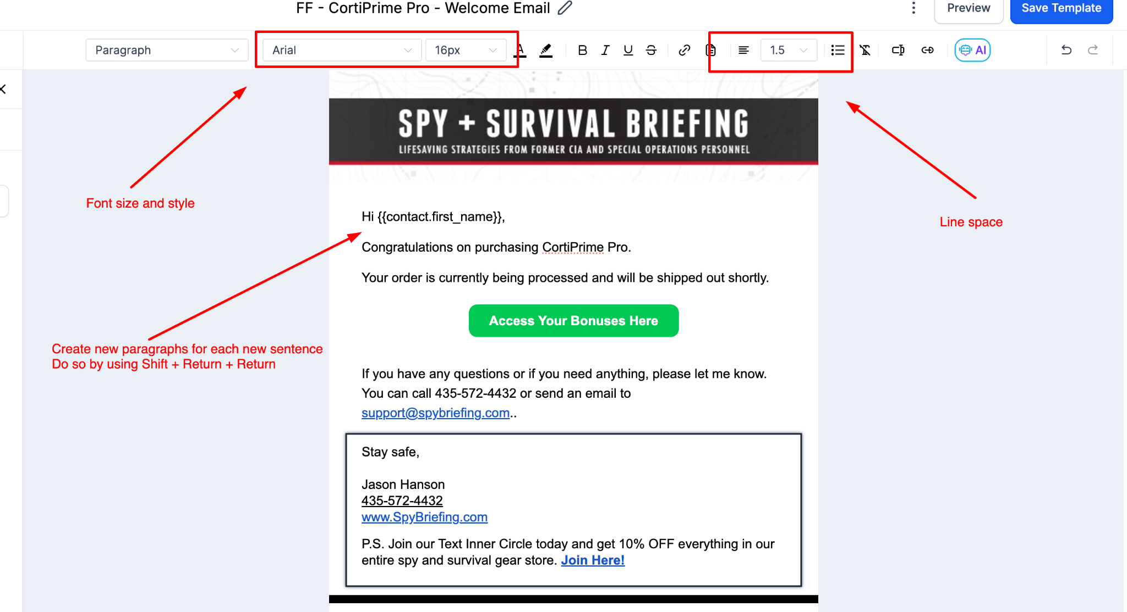
Watch this video as a guide.

Creating Invoices Using Webhook Automations in GHL
Invoices are stored in the Invoice Folder in GHL. The recommended method for creating a new invoice is to clone an existing one and make the necessary edits rather than building from scratch.

Step 1: Clone an Existing Invoice
- Navigate to the Invoice Folder
- Locate an existing invoice
- Click Clone
- Proceed to make your edits on the cloned invoice

Step 2: Understand the Two Webhooks
Every invoice automation contains two custom webhooks:
Webhook | Purpose
Webhook #2 (Store) | Saves the invoice data to the database
Webhook #3 (Retrieve) | Retrieves the data for the receipt email
The numbers assigned to each webhook are critical. These numbers must match across the workflow and the receipt email settings.

Step 3: Match the Webhook Numbers
This is the most important step. The webhook number in the workflow action must match the webhook number referenced in the receipt email.
Example:
- If the store webhook is #2, the URL in that workflow action must reference webhook 2
- If the retrieve webhook is #3, the receipt email must reference webhook 3
- If the retrieve webhook is #7, the receipt email must reference webhook 7
Rule: Whatever number appears on the custom webhook step, that same number must appear in the corresponding receipt email setting.

Step 4: Verify the Receipt Email Settings
- Open the Receipt Email in the workflow
- Check the settings/body of the receipt
- Confirm the webhook number referenced matches the retrieved webhook number in the workflow

⚠️ Important Notes
- When cloning an existing invoice: The webhook numbers should already be correctly matched. You typically do not need to change them.
- When copying a webhook manually: The numbers may not auto-update. Always verify all three references match:
  - The webhook step number
  - The URL in the workflow action
  - The webhook number in the receipt email

Adding New Products
Log in to the GoHighLevel account and navigate to the Payments section. Select "Products" from the top menu, then choose Create Product.
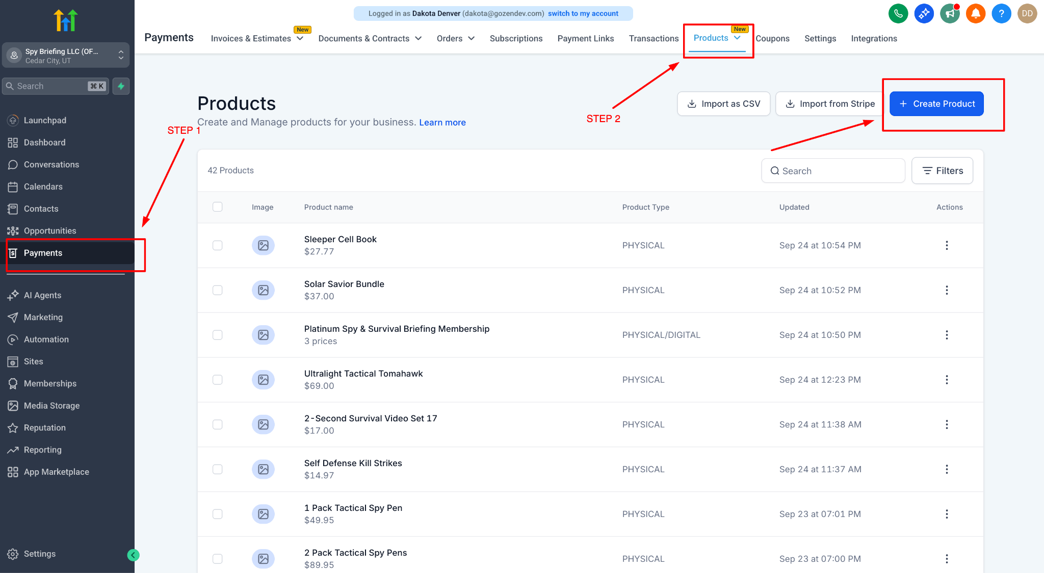
Fill Out Product Information: Complete all required fields and provide accurate information about the new product. Set the tax settings to As Per Global Settings. Also, enter the price for the product and choose if it's a subscription, one-time order, etc.
Watch this video as a guide.

Adding A Countdown Timer
In order to add a countdown timer in GHL, you can find it under Elements, then Saved Assets. There is a countdown timer that is already saved there, and that is the one you drag to the funnel section or column, depending on where you intend to use it.
Once this timer expires, it will disappear. The next step is to create a custom HTML element and add the code below to it.
<style>
.timer-wrap {
text-align: center;
padding: 10px 0;
font-family: 'Roboto', sans-serif;
}
.timer-grid {
display: inline-flex;
gap: 10px;
justify-content: center;
}
.timer-block {
display: flex;
flex-direction: column;
align-items: center;
min-width: 80px;
}
.timer-num {
font-size: 48px;
font-weight: 700;
color: #e93d3d;
line-height: 1;
}
.timer-label {
font-size: 13px;
color: #e93d3d;
margin-top: 4px;
text-transform: lowercase;
}
.timer-sep {
font-size: 48px;
font-weight: 700;
color: #e93d3d;
line-height: 1;
align-self: flex-start;
padding-top: 2px;
}
</style>
<div class="timer-wrap">
<div class="timer-grid">
<div class="timer-block">
<div class="timer-num">0</div>
<div class="timer-label">hours</div>
</div>
<div class="timer-sep"></div>
<div class="timer-block">
<div class="timer-num">0</div>
<div class="timer-label">minutes</div>
</div>
<div class="timer-sep"></div>
<div class="timer-block">
<div class="timer-num">0</div>
<div class="timer-label">seconds</div>
</div>
</div>
</div>
Once the custom HTML is created, go ahead and hide that element.
Go back to your original countdown timer and, in the contextual menu, choose Show & Hide Element. From there, choose Show Elements, then select the custom HTML you created and hid.
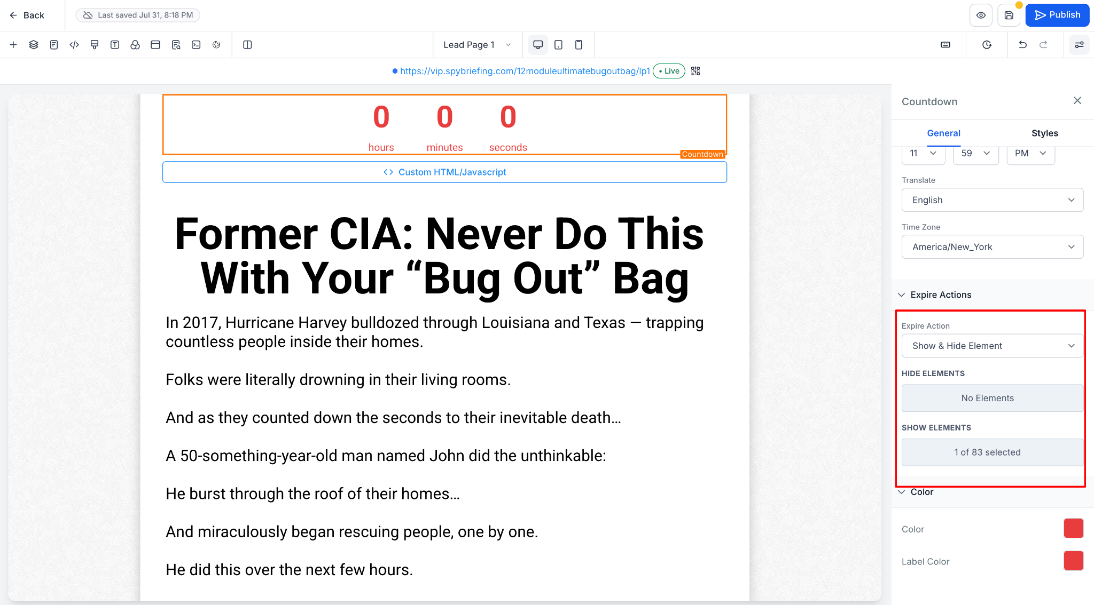

How to shut down the page
In order to shut down a page in GHL, you use a countdown timer, but you will use the one that is hidden. You can find it under Elements, then Element Templates. Select the asset that says SHUTDOWN PAGE and drag it onto the funnel. From there, you will select the time you want the page to shut down and add a redirect URL.

There is a countdown timer that is already saved there, and that is the one you drag to the funnel section or column, depending on where you intend to use it.

